2017 BOARD FORWARD

Michigan Recycling Coalition

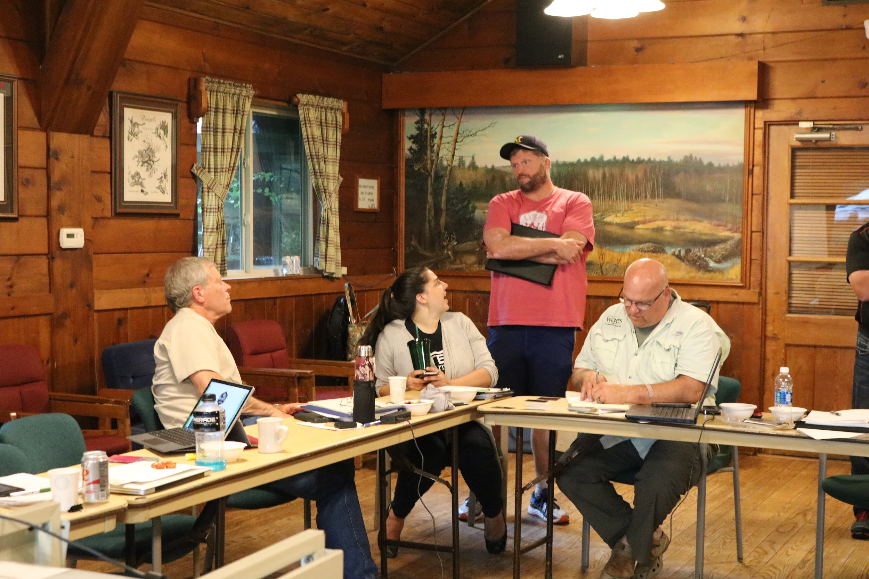

# NOTES:

Kerrin- More mature organization boards tend to have a strong fundraising focus, we may never reach that level because of who we are and our membership focus.

Dan-Been on other boards and likes that this one. It is more engaged and active. Likes helping be involved in MRC operations etc.

Kerrin-It’s all of our job to bring members into the organization. Membership is a shared responsibility.

Roger- What I’m hearing you say is having a potential member list is something we need because staff isn’t out in the community

Kerrin- What I was trying to say, staff isn’t out in the community like board members are. We don’t know who is looking for resources. Staff is good at seeing and sharing the value and can connect, but would like to let everyone know it is something we all should be investing our energy and time into.

Jake- I think we need to revisit role between staff and BOD getting members.

Kerrin- Yes, committee needs to understand best way.

Bill G- Regional outreach also is crucial for membership.

**Budget:**

Kerrin – We will end up on the positive side at the end of this year.

Roger – Over and above sponsorship money his year was how much?

Kerrin - $153,000 was made through sponsorship this year. Money over $100,000 was supposed to be used for Midwest Strategy Group. For this budget, I took expenses from last year and projected them forward, adding money for retirement, adding money for marketing consultant, adding money for website work. Padded areas where we might need something. Haven’t decided anything yet. On the revenue side, I zeroed out the budget based on adding things. Under revenue membership assumptions, the last set of numbers assumes significant membership growth. What we need to do is right-size our expectations for membership and adjust accordingly. Bottom where we project 50 members under Recycle, MI Supporters comes out of Dave’s strategy, not thin air. Other things – need to be strategic about how we’re going to accomplish that. The other thing is if you go to the revenue side - “event registration” - we bumped that revenue up because we think we’re going to have to hold another event in order to meet our budget and mission needs. Need to spend a little money to make a little extra money. The other place is grants and contracts. One of the things we’ve been working on over the summer is that the Ecology Center came to us about updating the Master Recycler manual. They’re paying $5,000 for that. There are some things we are working on that allows us to add to our budget. Wanted to show you this so you could get familiar with it as we are having these conversations. Questions or thoughts?

**Big Goals:**

Any feedback, comments, questions on this,

Reviewing the pre-Forward survey

**Lead**

- Policy and conference were resounding themes

**Educate**

- Should be a component of everything that we do

- What education resources are out there? Can we make the people who have the resources members? Can we provide that content to our members to provide a larger benefit?

**Mobilize**

Rick – telling stories about what people are doing. Putting it in a context.

Kerrin – our legislators really need to understand what is needed.

Roger – glass & rubber in Petoskey? That’s the best story we have.

Kerrin – would love board help finding those stories.

Bill G – someplace other than our website for highlighting these?

Kerrin – Yes. Our goal is to move a particular legislator to a particular position by telling this story and having the angle.

Bill G – Good for MRC and the people they are highlighting.

Dan – people blast stories.

Bill G – today’s technology, it gets spread to different social networks.

Dave – that’s what we do for Recycle, MI. Feature on website, social media posting, etc.

Bill G – LinkedIn etc. Makes other people think they should be a member/partner/whatever.

Katie – ready-to-go press releases are a good selling point.

Roger – maybe we should reach back out to Pure Michigan again?

**Budget**

NRC- Kerrin explains the opportunity.

SK- Great opportunity, and if you as ED are saying this is something you want to pursue, SK trusts you that this is a good opportunity if Kerrin is going to say it is. Go get it - great opportunity incorporating what it means to us and if the NRC is housed in Lansing MI. Kerrin would tell us this isn’t a good idea.

Rob- Get more info, if the benefits of it there and the resources are there, if it outweighs the cost be supportive

Rick- Agree, 6 month contract, not going to have a mentor, identify landmines and understand the lay of the land, may want a longer initial contract, 12 month makes more sense

Dan- There is a reason that you were hired

Dave- Trust Kerrin’s instincts, elevates the MRC

Roger- Struggle with the capacity that we have, not sure if we have the capacity to handle this. Sometimes we are strained and NRC has been struggling for a long time.

Jake- Time commitment from the business aspect takes away from the MRC, time spent family wise that balance. Dangerous for 6 months, and they go somewhere else.

Bill H- Trusts what happens, it’s a longer term commitment. And maybe additional person who can help with membership. Knows that Kerrin will do what’s best

Bill G- Lots of concerns, lots of work to see if they’d want to accept it, how do they support the work, where does the money go, your payment, how much time gets away from the MRC. Burning candle at both ends, but sees possibility.

Don P- Great feather in your cap that that tells me how valuable you are. NRC large unknown that needs to be dealt with, and do you have a plan are we able to make a plan that will be good for all parties? We are doing better than we ever have, and to take our star pitcher to put it on the bench, is that wise for the MRC, potentially a great asset for the MRC for what you can learn what you can gather, 5 years from now NRC is a great

Marybeth R- Trust thoughts on get a consultant fee, if they do extend.

Sarah K- Make sure a business plan is created that would allow both organizations to move forward together a great business plan. Make sure both can accomplish their goals.

# COMMITTEE PLANNING:

**Groups:**

1. Conference Committee - Sarah, Bill H, Jake, Mary Beth
2. Membership - SK, Bill G, Dan, Roger
3. Organics - Dave, Don, Robert, Rick
4. Policy - Roger, Rob, Rick, Sarah
5. Recycle, MI - Mary Beth, SK, Bill G, Dave
6. Regional Outreach - Don, Jake, Dan, & Bill H

**Committee Mission:**

1. Conference Committee -
   1. Create an event that fosters education, training, and networking opportunities around sustainable materials management through sponsorships, exhibitors, and membership in the Michigan Recycling Coalition.
2. Membership Committee -
   1. ?
3. Michigan Organics Council -
   1. Bring together organics generators, processors, and end users to network, share best practices, and promote diversion and utilization.
4. Policy Committee -
   1. Advocate for MRC’s mission through creation of a strategic policy and implementation plan.
5. Recycle, MI Committee -
   1. Foster the engagement of recycling participation and direction to the action for the betterment of the environment. *(Foster direct action, engagement, and participation in recycling program for the betterment of the environment.)*
6. Regional Outreach Committee -
   1. Bring together and create opportunity for members and potential members to share, network, *(to accomplish collective goals, provide MRC with input and feedback)*, and promote recycling.

**Committee Vision:**

1. Conference Committee -
   1. We envision providing a dependable, adaptive, best-in-class conference that is welcoming, vibrant, and forward thinking for attendees, sponsors, and exhibitors.
2. Membership Committee -
   1. Create data driven membership strategy. (?)
3. Michigan Organics Council -
   1. We envision a professional council that embraces the varied industry stakeholders and promotes education and best end utilization of organics.
4. Policy Committee -
   1. Remain focused on dynamic best in class data mission with a dynamic approach.
5. Recycle, MI Committee -
   1. We envision all Michiganders engaging in recycling where they work, live, and play.
6. Regional Outreach -
   1. We envision welcoming open-minded, cutting edge organizations who are dependable and think practically about recycling.

**How can the committee best contribute to the MRC over the next year?**

1. Conference Committee -
   1. Fill exhibit hall
   2. Review and revise sponsorship levels/benefits as needed
   3. Summit structure, ensure successful DEQ involvement in conference
   4. Work with regional outreach to promote conference
   5. Provide a list of keynote speakers and sessions (to who?)
2. Membership Committee -
   1. Track people who show up at regional meetings and become a member. By categories.
   2. Track number of people/companies invited/tools shared.
   3. Track number of members lost and why.
   4. Why are people members? - retention
   5. Recover expired members
3. Michigan Organics Council
   1. Market development
   2. Policy
   3. Infrastructure development
   4. Regulations
   5. Education and promotion
4. Policy Committee -
   1. Strategic plan policy driven & implement focused on talking points
   2. Work with DEQ to make sure our members goals and objectives
   3. Communication should be 2 way, create feedback opportunities
   4. Create a strategic policy plan and with MSG’s assistance implement
5. Recycle, MI Committee -
   1. Participate in regional outreach meetings
   2. Develop/promote newsletters/blogs/etc
   3. Be visible at the Conference
   4. Market products
6. Regional Outreach Committee
   1. Leadership in regions maintained
   2. Develop meeting content
   3. Member promotion
   4. Engage & invite new groups/organizations - sign up at region meetings
   5. Be accountable

**Committee Recruitment Goals & How to Achieve:**

1. Conference Committee - 15
   1. Email to recruit & send to members
   2. Regional Outreach
   3. Member prospects - email
2. Membership Committee - 0
   1. None
3. Michigan Organics Council - 0
   1. Focus on attracting organic stakeholders to MOC meetings
4. Policy Committee - 0
   1. None
5. Recycle, MI Committee - 3-8
   1. Match expertise with goals/needs of committee
   2. E-mail to members
6. Regional Outreach Committee - 18-20
   1. Ask

**Projects:**

1. Conference Committee -
   1. None
2. Membership Committee -
   1. SK - ask 3 haulers list of recyclers “sponsor” for data they have
   2. Recycle partnership - may have issue
3. Michigan Organics Council -
   1. None
4. Policy Committee -
   1. Establish structure for increased communication with MOC
5. Recycle, MI Committee -
   1. Finalize & launch individual supporter program
   2. Stadium membership
   3. Recycle, MI Newsletter
   4. Grow partners
6. Regional Outreach Committee -
   1. Regional partners

**How will committee contribute to Big Policy Goal?**

1. Conference Committee
   1. Policy education at conference
   2. Partnership w/DEQ - long term goals
   3. Provide opportunities for members to interact w/legislators
2. Membership Committee
   1. Survey to members would include policy questions
   2. Provide policy and legislators in their region (prospects)
   3. Identify which lists we need as prospects & interests
3. Michigan Organics Council
   1. Highlight policy efforts to MRC BOD and policy committee
   2. Exploring other policy opportunities
   3. Develop organic focused infographic
4. Policy Committee
   1. None
5. Recycle, MI Committee
   1. Raise awareness
   2. Supporters can host legislative tours
   3. Assist with stories
6. Regional Outreach
   1. Share info at meetings, bring feedback to staff/board
   2. Tours set up at meeting
   3. Ask & invite in the 40 stakeholders

**How will committee contribute to Big Membership Goal?**

1. Conference Committee
   1. Target west MI business & staff to join MRC
   2. Recruit local recycling businesses to join conference committee and encourage membership
   3. Attend regional outreach & promote committee & conference
2. Membership Committee
   1. Renewal survey development & implementation
   2. Prospect “ask” campaign - identify the lists & ask. Develop prospect list & method
   3. Meeting strategy with the lower organizations
3. Michigan Organics Council
   1. Leverage USCC partnership
   2. Highlight “state of organics” via webinar
   3. Identify organics stakeholders (that are non-members)
4. Policy Committee
   1. 2-way communication
5. Recycle, MI Committee
   1. Newsletter promotion of training
   2. Promote MRC & membership
   3. Promote regional outreach meeting & recognize player
6. Regional Outreach Committee
   1. Directors will help develop the prospects list - receive list from head of MRC
   2. Promote members at the meeting - sponsorship, social media, newsletters
   3. Consistently invite existing members to meetings & check in

**How will committee contribute to Big Conference Goal?**

1. Conference Committee
   1. Market conference to reach 400+ attendance goal
   2. Fill exhibit hall
   3. Fit the DEQ Summit into MRC conference and achieve a positive experience
   4. Review sponsor benefits and refine options
2. Membership Committee
   1. Glean the current members & new to increase attendees
   2. Send new members a marketing packet including conference
3. Michigan Organics Council
   1. Organics track
   2. MOC/organics stakeholder outreach
   3. Zero waste effort
4. Policy Committee
   1. Track or policy training
5. Recycle, MI Committee
   1. Promote Conference in newsletter
   2. Promote Recycle, MI partners at luncheon/conference
   3. Recycle, MI individual supporter discounts to conference
6. Regional Outreach
   1. 20 new members - offer incentives to combine registration
   2. Conference mixer, new members get free drink, tickets informal
   3. Put up a video at beginning of meeting highlighting conference and sponsorship

**3 BIG Committee Goals**

1. Conference Committee
   1. Save the date sent out Jan. to all 7,000 contacts
   2. Develop sponsorship document (revised) and ala carte sheet for staff by September
   3. DEQ sessions defined by March
2. Membership
   1. None
3. Michigan Organics Council
   1. MI Ag Business Association - identify gaps in research, bring data together, sponsor their conference, consider a targeted webinar, get testimonials
   2. Outreach and education/development of marketing collateral (infographic and “landscaping the Great Lakes”)
   3. Engage MDOT (and county) to use compost
4. Policy Committee
   1. None
5. Recycle, MI Committee
   1. Recycle, MI Newsletter
   2. Launch Individual Partner Program
6. Regional Outreach Committee
   1. Each RD gets 4 new members/year - $$$
   2. Increase # of attendees compared to last year
   3. Find a $10,000 sponsor to conference mixer

# MARKER BOARD - Brainstorming

1. Education
2. Connecting/Networking
3. Storytelling “member only”
   1. Multi-media
   2. For target audience(s)
   3. Social Media - post every 2 days, highlight members (9 posts/week)
4. Promote what we have to prospects
5. Develop content for key stakeholders we want as members (what do you have to share)
   1. Chrysler/Ford, Toyota, WMU, GVSU…
   2. Downstream
   3. Suppliers
6. Hone & deliver membership ask - what’s in it for me?
7. Video - set-up
8. Publish member list - on conference program
9. What’s enough - what CONTENT do we not have/need
10. How do we engage folks?
11. Get big names/Fortune 500 companies
12. Member level benefits
    1. Social Media
13. Conference (exhibiting value)
14. Increase value of membership for business (promote business)
    1. Help me solve a problem & promote me - member for life
15. What does the membership see of value? What do they want?
16. Only capturing 5-10% of government market
17. SELL content - members come
18. Sell RRRASOC success, structure
19. Municipal customers mo9re valuable to us - we already service.
20. Need to identify resources we should/could/would provide, i.e. geo maps
21. Testimonials

# KAHOOT DATA

|  |  |  |
| --- | --- | --- |
| QUESTIONS/ANSWERS | NUMBER CORRECT | PERCENT CORRECT |
| Question 1 - Three truths and a lie! Fid the lie: The MRC supports, through resolution or policy position...Solid waste hierarchy, Reuse, **Solid waste surcharge**, Anti-scavanging | 4 | 36.36% |
| Question 2 - the 2006 conference had a theme. What was it? Moving on up...the recovery chain, iRecycle, On the Road to Recycle, **Techno** | 0 | 0% |
| Question 3 - In 2007, facing a financial crisis, the MRC disaffiliated from the NRC. How was this resolved? **Anonymous benefactor settled the debt with a loan to the MRC**, The debt was forgiven by the NRC, 3 board members chipped in to pay the debt, the MRC is still in arrears with the NRC | 2 | 18.18% |
| Question 4 - What years did Kerrin become MRC Executive Director? 1987 and 2002, **1995 and 2008**, 1993 and 2008, 1997 and 2010 | 4 | 36.36% |
| Question 5 - What does the line on this chart represent?  MRC Fund Balance 2008-present.JPG **MRC Fund Balance 2008-2016**, Michigan’s recycling rate 2008-2016, Recycling grants awarded 2008-2016, MRC Membership 2008-2016 | 5 | 45.45% |
| Question 6 - What year did Bill Gurn become chair of the MRC Board? 1998, 2003, **2008**, 2011 | 5 | 45.45% |
| Question 7 - In what year were these items on the agenda at board forward 1986, **1999**, 2008, 2016What year-.png | 0 | 0% |
| Question 8 - In 1998, MRC’s 16th annual conference was for the first time held in May. What was it called? **Recycling “Big Show,”** “SWAP” trash for recycling, “Impeach Garbage,” R2K - Recycling in the New Milennium | 4 | 36.36% |
| Question 9 - How many times has the MRC used an association management firm to manage MRC business? 0, 1, **2**, 3 | 2 | 18.18% |
| Question 10 - What does this chart show? Mystery Chart 2.JPGConference attendance/conference attendance revenue, Conference sponsors, conference sponsor revenue, **Member number/member revenue**, Grant hours worked/grant revenue | 3 | 30% |
| Question 11 - What is Katie most likely to be in the news for? **Ballot initiative creating a citizens redistricting commission**, Ballot initiative to regulate marijuana like alcohol, armed robbery, Grand Rapids improv | 7 | 63.64 |
| Question 12 - Which of these tasks is NOT in the Executive Director position description? Garner media attention w/press releases, interviews, etc, Board management, Provide leadership and policy guidance for the organization, **Recruit new MRC members** | 4 | 36.36% |
| Question 13 - Who is the longest-running MRC Board Member? **Unconfirmed** Dave Smith, Don Pyle, **Matt Flechter**, Bill Gurn | 0 | 0% |
| Question 14 - The Recycle, MI Campaign was launched in 2014. What was the original intention of Recycle, MI? Education and resource for voters on recycling policy, **Education resource for businesses/residents for recycling**, Recycling location designation for parks and municipalities, 2013 Conference theme | 6 | 54.54% |
| Question 15 - When did the MRC officially take a position on the Bottle Bill and what was that position? Support existence & expansion, 1996, Do not support, 2005, **Support expansion, 2005**, Support existence, not expansion, 2005 | 1 | 9.09% |
| Question 16 - What has contributed to the MRC’s recent success? Strong board, strong ED and staff, Successful Conferences, **All of the above** | 9 | 81.82% |